df.head()
Next steps: Generate code with df
New interactive sheet
print("Smart City Traffic Forecasting Project Started")

Smart City Traffic Forecasting Project Started
from google.colab import files uploaded = files.upload()

train_aWnotuB.csv
train_aWnotuB.csv(text/csv) - 1 81 5392 bytes, last modiﬁed: 5/27/2026 - 1 00% done
Saving train_aWnotuB.csv to train_aWnotuB (1).csv
Choose Files
import pandas as pd
import matplotlib.pyplot as plt import os
os.listdir('/content')

['.config', 'train_aWnotuB (1).csv', 'train_aWnotuB.csv', 'sample_data']
df = pd.read_csv('/content/train_aWnotuB.csv')

 | DateTime | Junction | Vehicles | ID
 | 0 201 5-1 1 -01 00:00:00 | 1 | 1 5 | 201 51 1 01 001
 | 1 201 5-1 1 -01 01 :00:00 | 1 | 1 3 | 201 51 1 01 01 1
 | 2 201 5-1 1 -01 02:00:00 | 1 | 1 0 | 201 51 1 01 021
 | 3 201 5-1 1 -01 03:00:00 | 1 | 7 | 201 51 1 01 031
 | 4 201 5-1 1 -01 04:00:00 | 1 | 9 | 201 51 1 01 041

df.columns

df.describe()

Index(['DateTime', 'Junction', 'Vehicles', 'ID'], dtype='object')
df.shape

(48120, 4)
df.info()

<class 'pandas.core.frame.DataFrame'> RangeIndex: 48120 entries, 0 to 48119 Data columns (total 4 columns):
# Column Non-Null Count Dtype

- DateTime 48120 non-null object
- Junction 48120 non-null int64
- Vehicles 48120 non-null int64
- ID 48120 non-null int64 dtypes: int64(3), object(1)
memory usage: 1.5+ MB

 | Junction | Vehicles | ID
count | 481 20.000000 | 481 20.000000 | 4.81 2000e+04
mean | 2.1 80549 | 22.791 334 | 2.01 6330e+1 0
std | 0.966955 | 20.750063 | 5.944854e+06
min | 1 .000000 | 1 .000000 | 2.01 51 1 0e+1 0
25% | 1 .000000 | 9.000000 | 2.01 6042e+1 0
50% | 2.000000 | 1 5.000000 | 2.01 6093e+1 0
75% | 3.000000 | 29.000000 | 2.01 7023e+1 0
max | 4.000000 | 1 80.000000 | 2.01 7063e+1 0

df.isnull().sum()
0
DateTime 0
Junction 0
Vehicles 0
ID
0
dtype: int64

df = df.dropna()
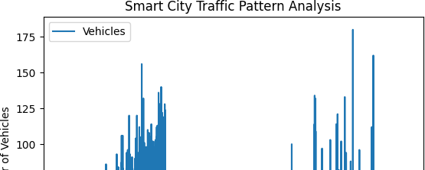
df.isnull().sum()
0
DateTime 0
Junction 0
Vehicles 0
ID
0
dtype: int64
df.plot(x='DateTime', y='Vehicles', kind='line')

plt.title("Smart City Traffic Pattern Analysis") plt.xlabel("Date and Time")
plt.ylabel("Number of Vehicles") plt.show()
top5 = df.groupby('Junction')['Vehicles'].mean().sort_values(ascending=Fals top5.plot(kind='bar')
plt.title("Top 5 High Traffic Junctions") plt.xlabel("Junction")
plt.ylabel("Average Vehicles") plt.xticks(rotation=45)
plt.show()

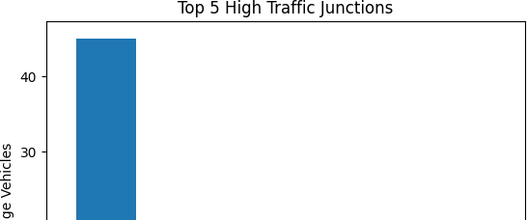
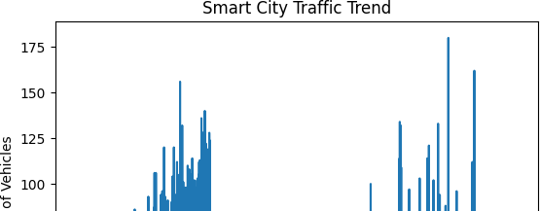
traffic = df['Vehicles'] plt.plot(traffic)
plt.title("Smart City Traffic Trend") plt.xlabel("Time")
plt.ylabel("Number of Vehicles")

plt.show()
df.to_csv("cleaned_traffic_data.csv", index=False)
print("Smart City Traffic Forecasting Project Completed")

Smart City Traffic Forecasting Project Completed

